8. Depth First Search (DFS)
Aim
To write a Python program to implement Depth First Search (DFS).
Procedure
- Start from the source node.
- Mark the node as visited.
- Visit an unvisited adjacent node.
- Continue until no unvisited adjacent node remains.
- Backtrack and visit remaining nodes.
- Continue until all nodes are visited.
Program
graph = { 'A': ['B', 'C'], 'B': ['D', 'E'], 'C': ['F'], 'D': [], 'E': [], 'F': []}visited = set()def dfs(node): if node not in visited: print(node, end=" ") visited.add(node) for neighbour in graph[node]: dfs(neighbour)dfs('A')
Output:
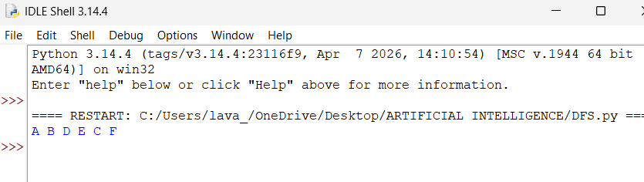
Result
Thus, DFS was successfully implemented using recursion.

